***Using the Request Module to Get Data from an API***

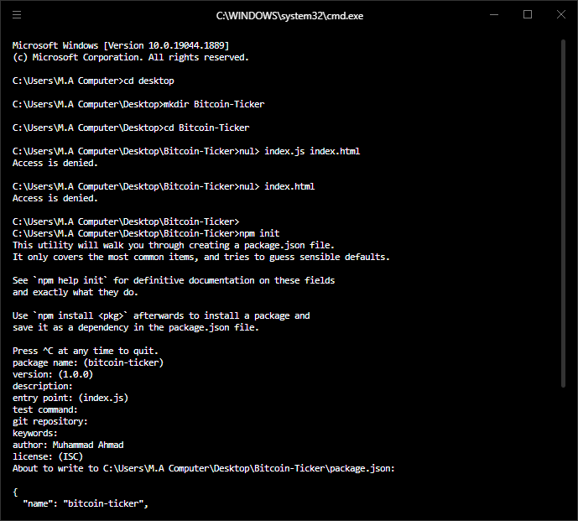

Install express body parser



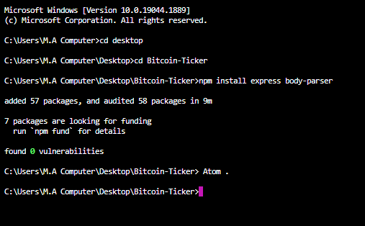

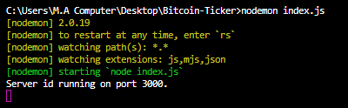

Search http request to external server

<https://stackoverflow.com/questions/40222563/how-to-make-a-external-api-call-inside-express-server>

<http://www.npmjs.com/package/request>

**install npm request**

everything started with **2** means successful.

<https://developer.mozilla.org/en-US/docs/Web/HTTP/Status>

